Creating wireframes and design layouts for a **Bookstore Management System** involves visualizing the structure of the website and how users will interact with it. Below is a detailed outline of wireframes and design layouts for key pages within the system

**1. Home Page Layout:**

**Purpose:** This page serves as the landing page for the bookstore, showcasing featured books, categories, and a search bar.

**Wireframe:**

* **Header:**
  + Logo on the left.
  + Navigation links on the right: Home, Books, Categories, Cart, Login/Sign Up.
  + Search bar in the center for quick book search.
* **Main Section:**
  + **Featured Books Carousel**: Display a carousel for featured books, with cover images, titles, and prices.
  + **Categories Section**: Below the carousel, display different book categories (e.g., Fiction, Non-Fiction, Science, Romance).
  + **Best Sellers**: A grid of books that are bestsellers, with cover images, prices, and a brief description.
* **Footer:**
  + Contact info, privacy policy, terms of service, social media links.

**2. Books Listing Page Layout:**

**Purpose:** This page lists all the books available for sale, with filtering options.

**Wireframe:**

* **Header:** Same as the home page.
* **Sidebar Filters Section:**
  + Categories filter (e.g., Fiction, Non-Fiction).
  + Price range slider.
  + Rating filter (e.g., 4 stars and above).
  + Author filter.
* **Main Content:**
  + **Books Grid**: A grid layout displaying book cards (with cover image, title, author, price, rating).
  + **Pagination/Load More**: Option to load more books or paginate.
* **Footer:** Same as the home page.

**3. Book Details Page Layout:**

**Purpose:** This page provides detailed information about a specific book.

**Wireframe:**

* **Header:** Same as the previous pages.
* **Main Section:**
  + **Book Cover**: Large image of the book cover on the left.
  + **Book Details**: Title, author, price, rating, and short description on the right.
  + **Add to Cart Button**: Prominent button to add the book to the shopping cart.
  + **Reviews Section**: List of user reviews, with the option to add a new review.
  + **Related Books**: At the bottom, display books similar to the one being viewed.
* **Footer:** Same as the home page.

**4. Login and Registration Pages Layout:**

**Purpose:** These pages allow users to log in or register for the bookstore.

**Wireframe:**

* **Login Page:**
  + **Email and Password Fields**: Input fields for email and password.
  + **Submit Button**: A button to log in.
  + **Forgot Password Link**: A link to reset the password if forgotten.
  + **Sign Up Link**: Link to switch to the registration page.
* **Registration Page:**
  + **Name, Email, Password Fields**: Input fields for user details.
  + **Submit Button**: Button to complete registration.
  + **Login Link**: A link to switch to the login page.

**5. Admin Dashboard Layout:**

**Purpose:** The admin dashboard provides book management tools and reports.

**Wireframe:**

* **Header:** Logo on the left, admin navigation (Dashboard, Book Management, Order Management, Reports).
* **Main Section:**
  + **Overview Section**: Display stats such as total sales, active users, and book inventory.
  + **Book Management**: Grid of books with options to add, edit, or delete books.
  + **Order Management**: List of customer orders, including order status, customer details, and options to process the order.
  + **Reports Section**: Access to sales and customer reports.
* **Footer:** Same as the home page.

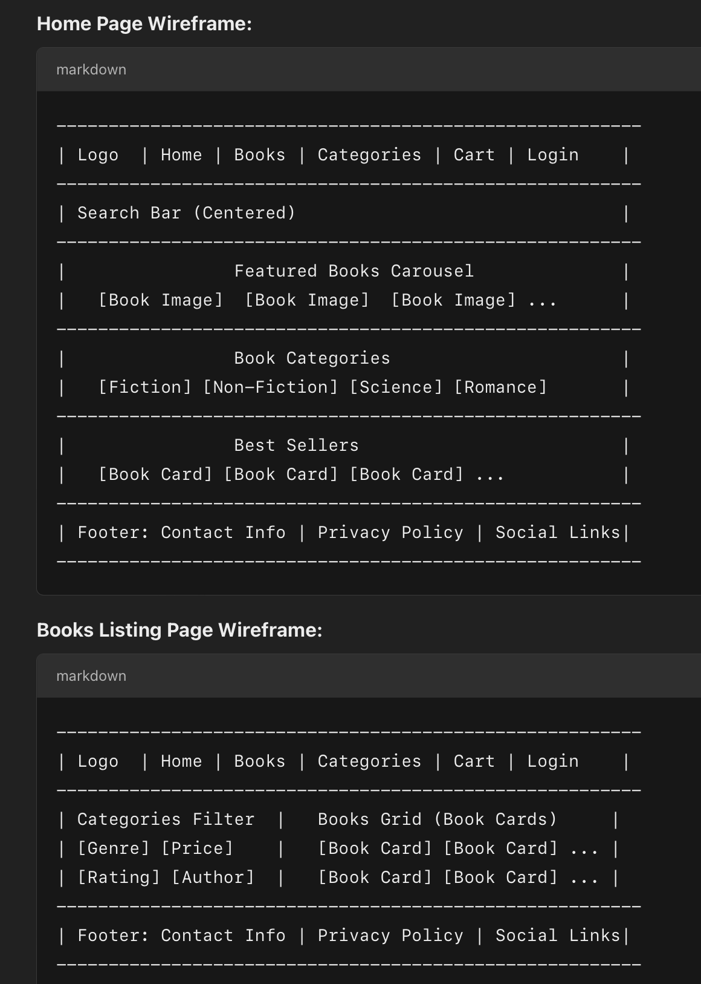

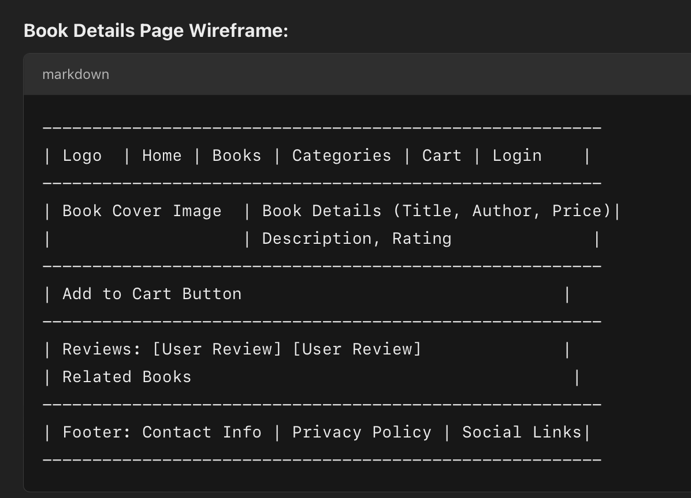

1. **Book Card** (A component for displaying book information in a grid).
2. **Book List** (A component for showing a list of books with filtering options).
3. **Search Bar** (A component to search for books).
4. **Login Form** (A component for user login).
5. **Responsive Layouts** using CSS Grid/Flexbox for a mobile-friendly design.

**1. Book Card Component:**

The **Book Card** component displays basic information about a book such as title, author, price, and cover image. It will be reusable in a grid layout to display all books.

**CSS for Book Card (Responsive):**

**2. Book List Component (with Filter):**

This component displays a list of books and allows users to filter them by categories, price, or rating.

**CSS for Book List (Responsive):**

**3. Search Bar Component:**

A search bar component that filters books by title.

**CSS for Search Bar (Responsive):**

**4. Login Form Component:**

This component allows users to log in to the bookstore system.

**CSS for Login Form (Responsive):**}

**5. Responsive Layout Using Flexbox/Grid:**

We’ve already incorporated **CSS Grid** for the book listing and **Flexbox** for the book card, but let’s make sure the entire layout is responsive:

**CSS for General Layout:**

To integrate **login forms** and **dynamic elements** tied to backend services for a **Bookstore Management System**, we need to handle the following:

1. **User Authentication** (Login).
2. **Storing and Using Authentication Tokens** (JWT).
3. **Fetching Data Dynamically** (e.g., book data) after login.
4. **Handling User Login State** (using React state or Context API).

These guidelines aim to establish a consistent structure, coding style, and best practices for front-end development of the Bookstore Management System. They will ensure that the codebase is maintainable, scalable, and easy for developers to collaborate on.

1. **Project Structure**

**2. Coding Style Guidelines**

**2.1. JavaScript / JSX Style**

* **Indentation**: Use 2 spaces for indentation. No tabs.
* **Semicolons**: Always use semicolons at the end of each statement.
* **Variable Declaration**: Use const for variables that are not reassigned and let when reassignment is necessary. Avoid using var.
* **Function Components**: Use function components over class components, and prefer arrow functions for event handlers and small functions.

**2.2. Naming Conventions**

* **Components**: Use PascalCase for component names.
  + Example: BookCard.js, LoginForm.js
* **Functions**: Use camelCase for function names.
  + Example: handleLogin(), fetchBooks()
* **Files & Directories**: Name files and directories in lowercase, separated by dashes for better readability.
  + Example: /components/book-card.js, /utils/api.js

**2.3. CSS / SCSS Guidelines**

* **CSS Modules**: Use CSS Modules for styling React components. This avoids naming conflicts and makes styles scoped to the component.

Example (CSS Module):

**3. Component Structure & Guidelines**

**3.1. Components**

* **Component Reusability**: Create small, reusable components. For example, the Button component should be used wherever buttons are required.
* **Component State**: Manage state locally when possible. Use Context API or a state management library like Redux for global state management (e.g., authentication state or cart state).

**3.2. Handling Forms**

For forms like **login**, **search**, or **add new book**:

* **State Management**: Use controlled components for form inputs.
* **Form Validation**: Validate form fields using simple checks or libraries like **Formik** and **Yup** for more complex forms.
* **Error Handling**: Display error messages clearly below or beside the form field. Use visual indicators like red borders for error fields.

**3.3. Component Communication**

* **Props**: Pass down data via props to child components.
* **Callbacks**: Use callbacks to pass data or trigger actions back from child components to the parent.

**4. State Management**

**4.1. Local Component State**

* Use **useState** for handling local state inside functional components (e.g., form input fields, toggle visibility).

**4.2. Global State Management**

For managing authentication state, shopping cart, etc., use:

* **React Context API** for simpler, small-scale apps.
* **Redux** for larger applications or when managing complex global state.

**5. Responsive Design**

**5.1. Mobile First**

* Start with the mobile design, and then use **media queries** to adjust the layout for larger screen sizes (tablet, desktop).
* Use percentages, vw, vh, rem, and em units for flexible and scalable layouts.

**5.2. Flexbox & Grid**

Use **Flexbox** and **CSS Grid** to create fluid, responsive layouts without worrying about floating elements or complex positioning.

**6. API Integration and Data Fetching**

**6.1. Axios for API Calls**

Use **Axios** to make HTTP requests and handle responses.

**6.2. Error Handling**

* Handle errors gracefully by displaying appropriate messages to users.
* Use try-catch blocks in async functions, and show an error message in the UI if data fetching fails.

**7. Authentication and Authorization**

**7.1. Token Management**

* Store the JWT token in **localStorage** or **sessionStorage**.
* Always send the token in the Authorization header for requests that require authentication.
* **7.2. Protected Routes**
* Use **React Router** and guard routes based on the authentication state.

**8. Testing**

**8.1. Unit Testing**

* Use **Jest** for unit testing your React components and utilities.
* Use **React Testing Library** to test component behavior and interactions.